https://www.hackerrank.com/challenges/grading/problem

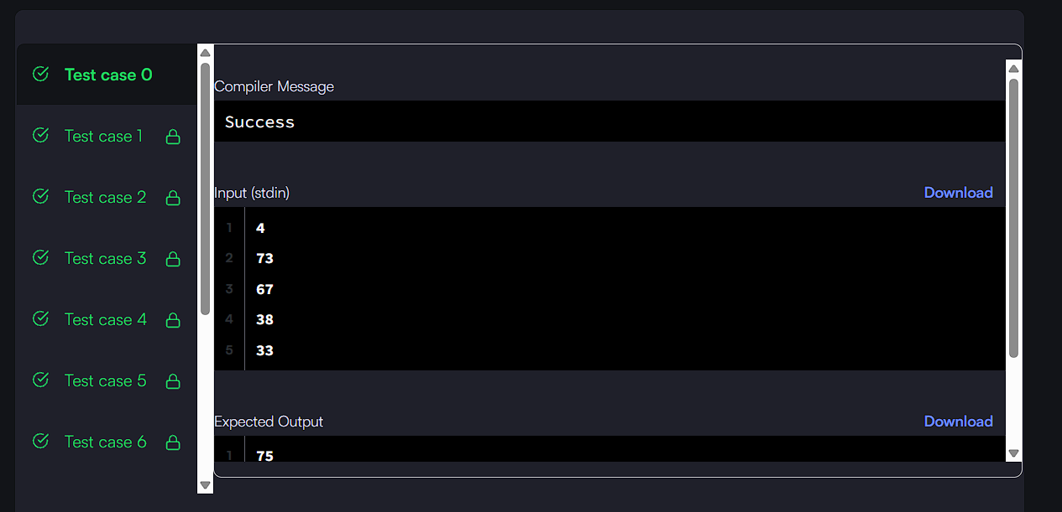

*result_count = grades_count;
int* result = malloc(grades_count * sizeof(int));

for (int i = 0; i < grades_count; i++) {
int g = grades[i];
if (g >= 38) {
int next = ((g / 5) + 1) * 5;
if (next - g < 3) {
g = next;
}
}
result[i] = g;
}

return result;

